Two ways of scheduled counting.

1. Using Schedule
2. Using Advanced Rule with VCA Pro License

Scheduled Count （Counting Line）= using Schedule

* Set schedules
* Disable or enable VCA countline, movebject.
* Disable or enbale VCA countline, moveobject

Example)

7:00~9:00, 14:00~16:00 >> count,

Not count exclude these terms.

1. Set schedule 7:00, 9:00, 14:00, 16:00
2. Set http push cgi command to enable VCA as   
   http://127.0.0.1/uapi-cgi/param.fcgi?action=update&group=VCA.Ch0&enablecntline=yes&enablemovobj=yes
3. Set http push cgi command to diable VCA as   
   http://127.0.0.1/uapi-cgi/param.fcgi?action=update&group=VCA.Ch0&enablecntline=no&enablemovobj=no
4. Binding 7:00 to enable, 9:00 to disable, 14:00 to enable, 16:00 to disable.
   1. Set set 07:00 schedule

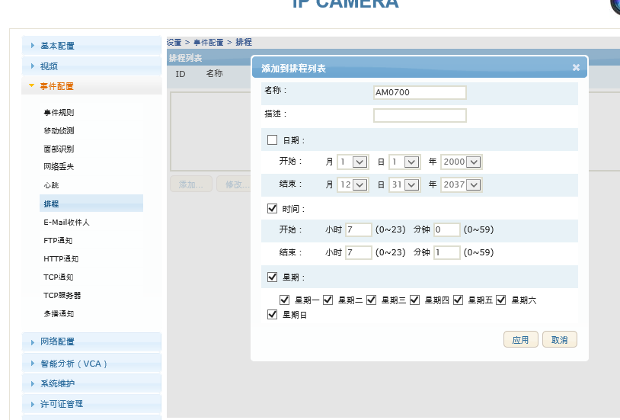

* 1. Set set 09:00 schedule

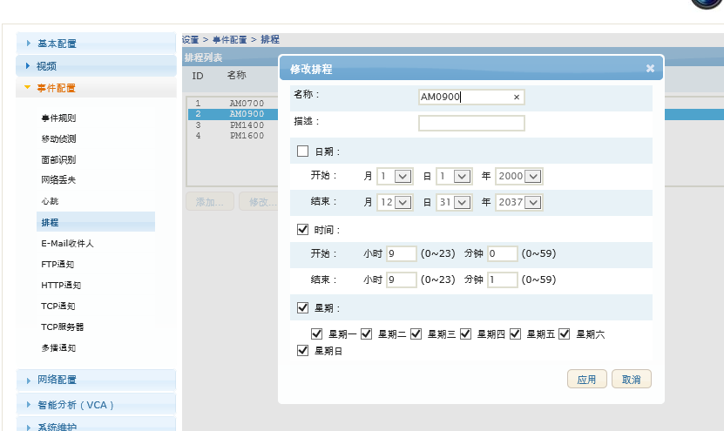

* 1. Set set 14:00 schedule

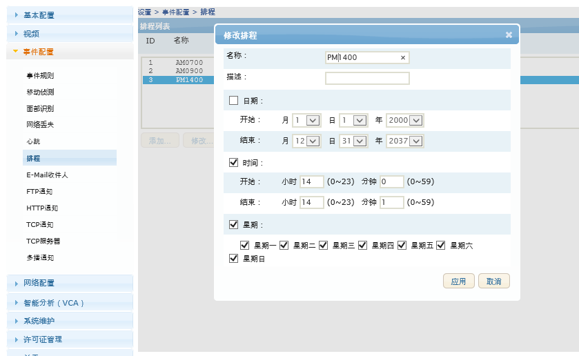

* 1. Set set 16:00 schedule

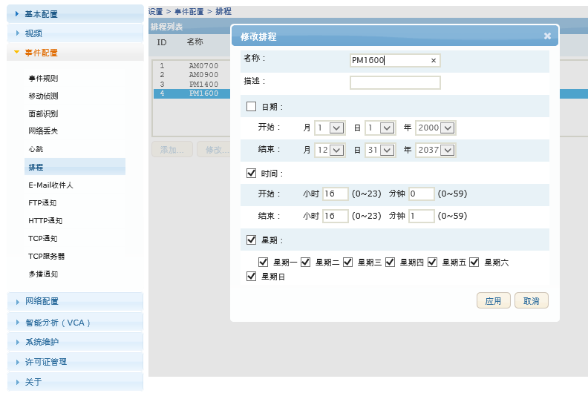

* 1. Enable VCA cgi command with http push

<http://127.0.0.1/uapi-cgi/param.fcgi?action=update&group=VCA.Ch0&enablecntline=yes&enablemovobj=yes>

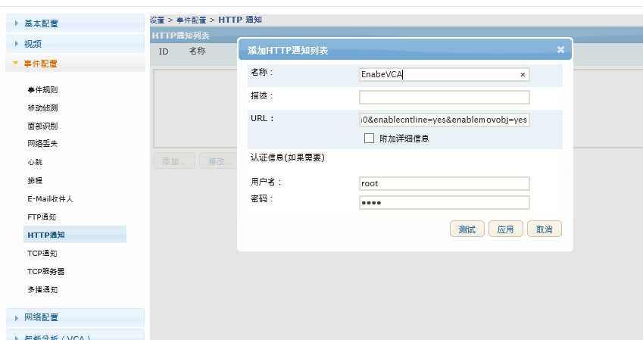

3-1) Enable VCA cgi command with http push

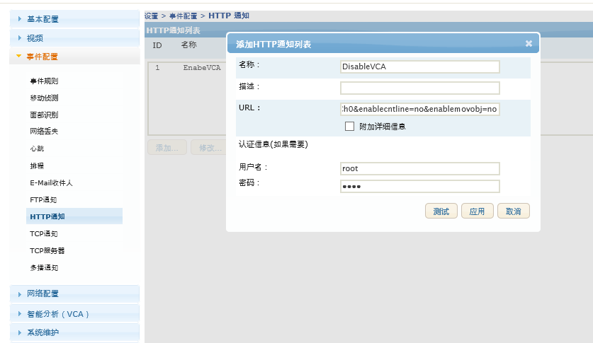

4-1) Linking Schdule AM0700 to VCAEnable

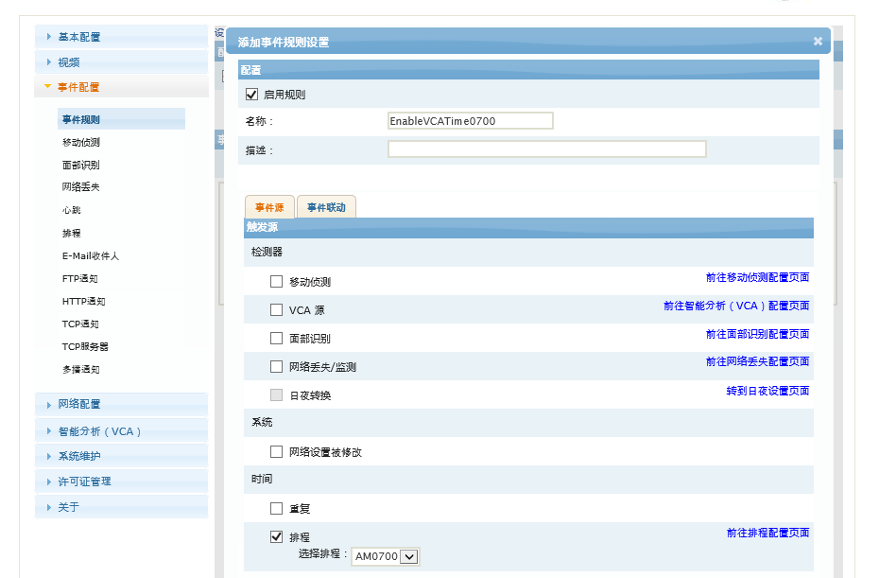

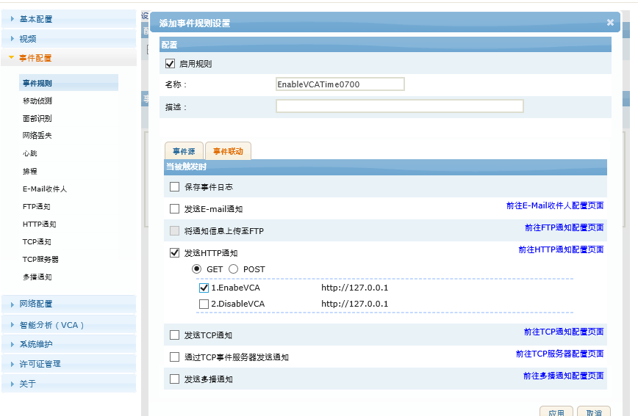

4-2) Linking Schdule AM0700 to VCAEnable

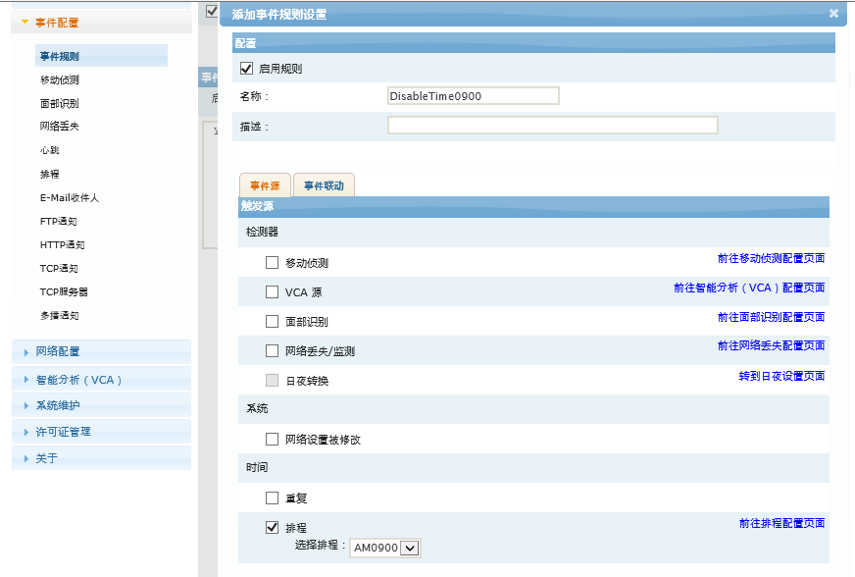

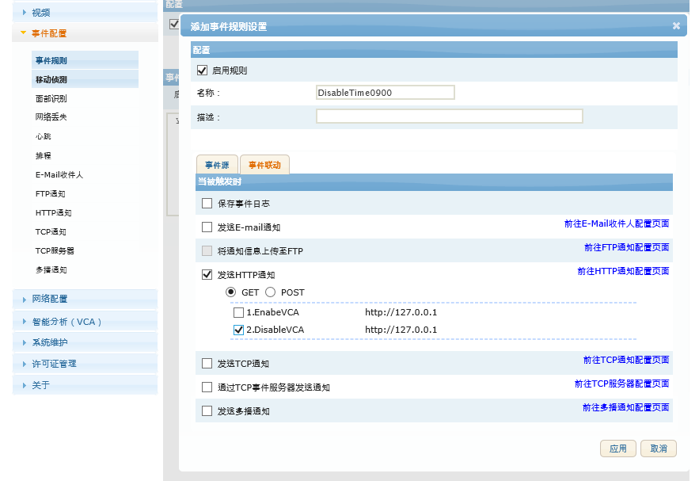

4-3) Linking Schdule AM1400 to VCAEnable

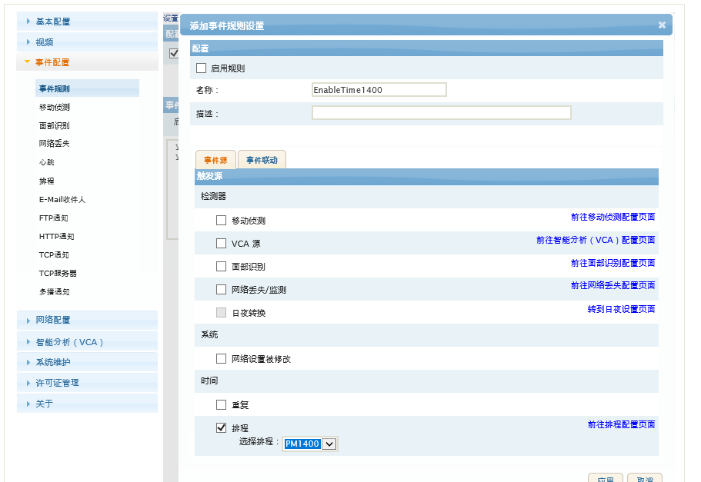

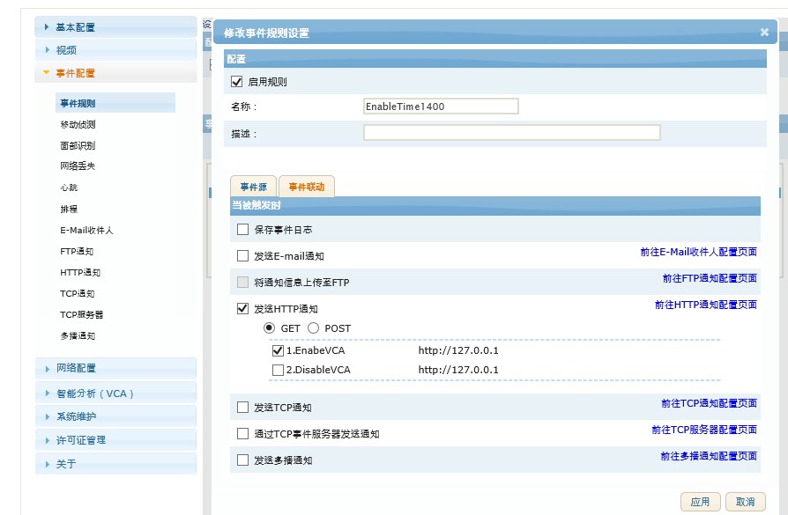

4-4) Linking Schdule AM1600 to VCADisable

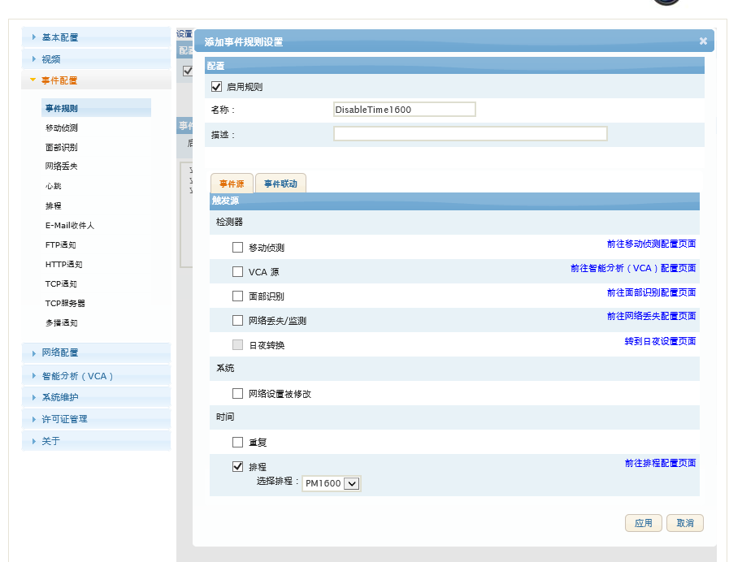

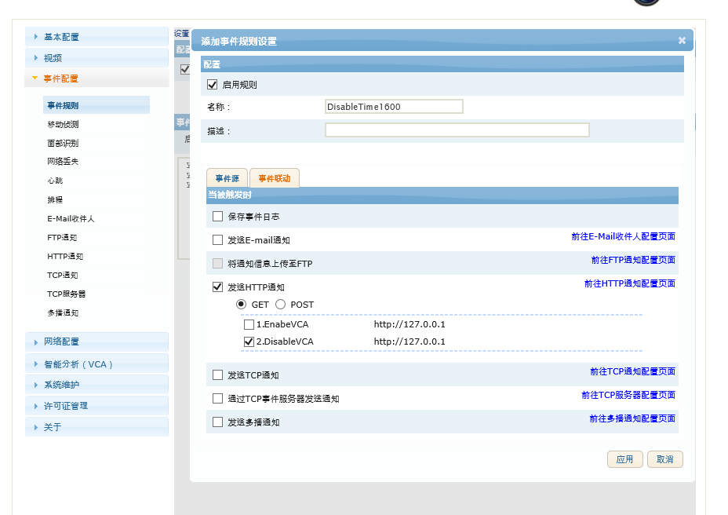

Alternative Ways (using advanced rule with VCA PRO)

